Ideation Phase
Brainstorm & Idea Prioritization

Date | 15 February 2026
Team ID | LTVIP2026TMIDS80893
Project Name | Rainfall Prediction System for Agriculture
Maximum Marks | 4 Marks

Step-1: Team Gathering, Collaboration and Select the Problem Statement
The team identified unpredictable rainfall patterns affecting agricultural planning. Farmers lack realtime, data-driven insights. The selected problem is to build a Machine Learning-based Rainfall Prediction System with agricultural advisory support.
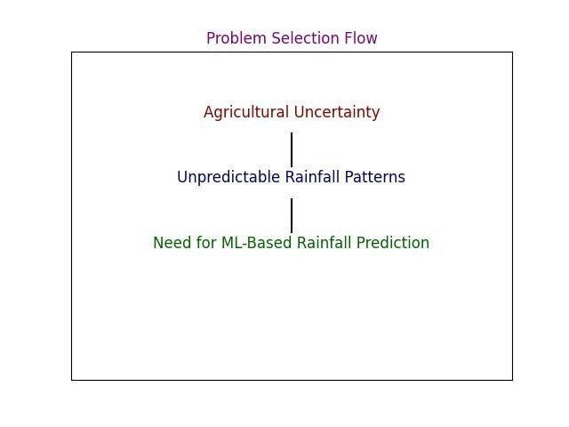
Step-2: Brainstorm, Idea Listing and Grouping Brainstormed Ideas:
- Perform Exploratory Data Analysis on rainfall dataset.
- Develop ML models (Logistic Regression, Random Forest, XGBoost).
- Deploy model using Flask Web Application.
- Provide dynamic agricultural advisory based on prediction.
Ideas were grouped into Data Analysis, Model Development, and Deployment categories.
Step-3: Idea Prioritization
Ideas were prioritized based on real-world impact, feasibility, innovation, and scalability. The complete ML + Web Application with advisory support received the highest priority.
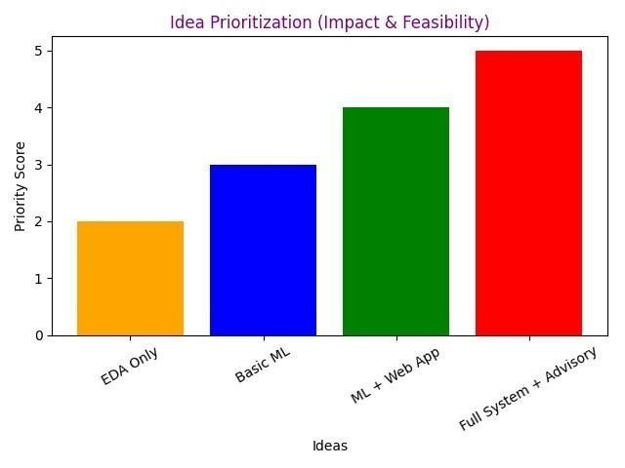

Final Selected Idea:
A Machine Learning-powered Rainfall Prediction Web Application to assist farmers in irrigation planning and crop management.

